Tansley in Bloom 2016

Competition Rules and Entry forms

Scarecrow Competition Page 2 Blue

Tansley in Bloom Competition Page 4 Green

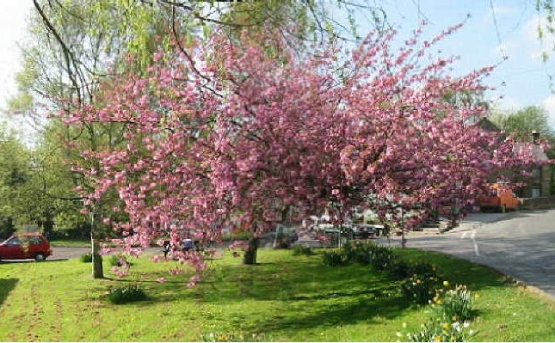

Entry to either Competition is Free!

Entry forms must be received by Sunday 26 June 2016 either by email at tansleyinbloom@btinternet.com or placed in the post box at the Tansley Community Hall, Church Street. Please allow sufficient time for entries to arrive. Please note - Unless encrypted, email messages passing over the internet are not secure and could be intercepted and read by someone else. Please bear this in mind when deciding what information to include in any email messages you intend to send.

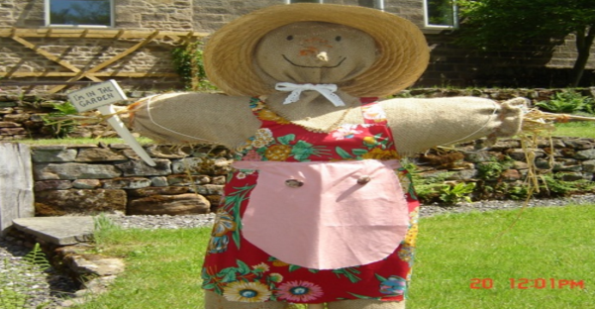 | Tansley in Bloom 2016  Scarecrow Competition Rules

The Competition is open to all residents within the settlement of Tansley including the school, organisations, clubs, churches, pubs etc. You must ensure that you comply with the Scarecrow competition rules before entering:-
- Your Scarecrow must be safely erected on your property and easily visible from the public footpath or highway, cannot fall over and cause an accident or injury to anyone
- Appropriate for public display - unsuitable Scarecrows will not be acceptable
- There is no theme but all Scarecrows must have a name
- Entry as 'Child' - child's own work with minimal adult help allowed
- Entry as 'Adult' - adult(s) only making Scarecrow
- Entry as 'Family' - children and adults involved in making the Scarecrow
- Scarecrows must be in place for viewing from 6.00p.m. on Sunday 3rd July
- Judging will take place during the week commencing 4th July
- Winners names and/or photos may be used to publicise the Tansley in Bloom 2016 competition
- Tansley in Bloom Committee takes no responsibility for any injuries or accidents caused by a Scarecrow entry.

SCARECROW COMPETITION 2016 – ENTRY FORM
By completing this form and entering the Scarecrow Competition you are deemed to have accepted, and will comply with, the Scarecrow Competition Rules.
Name
Address
Email address
My Scarecrow's name is
Entry class: Child or Adult or Family delete as appropriate
In line with the Data Protection Act 1998 all personal details will be deleted/ shredded within 7 days of the competition end date.
Any queries please email tansleyinbloom@btinternet.com or telephone Polly on (01629) 760565 before 8.00p.m.

Scarecrow Trail Map - competition to view all the Scarecrows

- Scarecrow Trail Maps will be available from Monday 4th July from the following locations :-
  - Tansley Parish Council website
  - Emailing tansleyinbloom@btinternet.com
  - Available at various locations around the village including Tansley Community Hall and Tansley Holy Trinity Church
  - Circulated on Tansley Hotwire.
- A mystery prize will be awarded for the correct completion of the Scarecrow Map. In the event of a tie the winner will be drawn from all who qualify. Entries must be placed in the post box at the Tansley Community Hall, Church Street by 11am on 9th July 2016.

Presentation of trophies and prizes for the Scarecrow Competition and Scarecrow Trail will take place from 3:30pm in the Tansley Village Hall on 9th July 2016.

Prizes - Scarecrow Competition

- 1st Prize Child entry - Craig Hardy Memorial Trophy
- 1st Prize Adult entry - Val Wildgoose Memorial Trophy
- 1st Prize Family entry - Tansley Parish Council Trophy.

Tansley in Bloom Competition 2016

The Competition is open to all residents within the settlement of Tansley including the school, organisations, clubs, churches, pubs etc. You must ensure that you comply with the Tansley in Bloom 2016 competition rules before entering:-

- Gardens/ hanging baskets, tubs or planters must be accessible to the Tansley in Bloom judges
- Owners must be present during the judging of their garden/ hanging baskets, tubs or planters
- Judging will be undertaken by Jeff Bates (East Midlands in Bloom) during the evening of 4th July
- Winners names and/or photos may be used to publicise the Tansley in Bloom 2016 competition.
TANSLEY IN BLOOM 2016 COMPETITION – ENTRY FORM
By completing this form and entering the Tansley in Bloom 2016 competition you are deemed to have accepted, and will comply with, the Competition Rules.
Name
Address
Email address
Telephone Number
Child Name & Age (If Applicable)
In line with the Data Protection Act 1998 all personal details will be deleted/ shredded within 7 days of the competition end date.

Category | Entry
Best Hanging Basket, Tub or Planter
Best Small Garden
Best Large Garden
Please ‘’ all categories that you would like to enter.

Any queries please email tansleyinbloom@btinternet.com or telephone Polly on (01629) 760565 before 8.00p.m

Prizes - Tansley in Bloom 2016

- 1st Prize Hanging Basket, Tub or Planter £10 Garden Voucher
- 1st Prize Small Garden £20 Garden Voucher
- 1st Prize Large Garden £20 Garden Voucher.

Presentation of prizes for the Tansley in Bloom 2016 Competition will take place from 3:30pm in the Tansley Village Hall on 9th July 2016.

